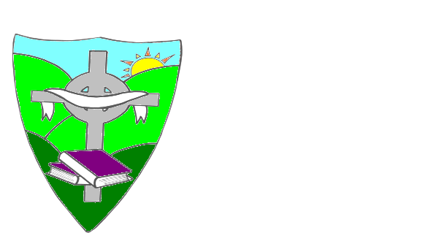

ST. MARY’S PRIMARY SCHOOL

REMOTE LEARNING AND TEACHING AGREEMENT

Name of Pupil: _______________________

Class: __________

I confirm that I have read the Remote Learning and Teaching Policy January 2021. A copy of this can be found on the school website.

I am happy to for my child to engage in online learning based on the expectations set out for pupils and parents in that policy.

Signed: ________________________
Parent

Date: ______________________

