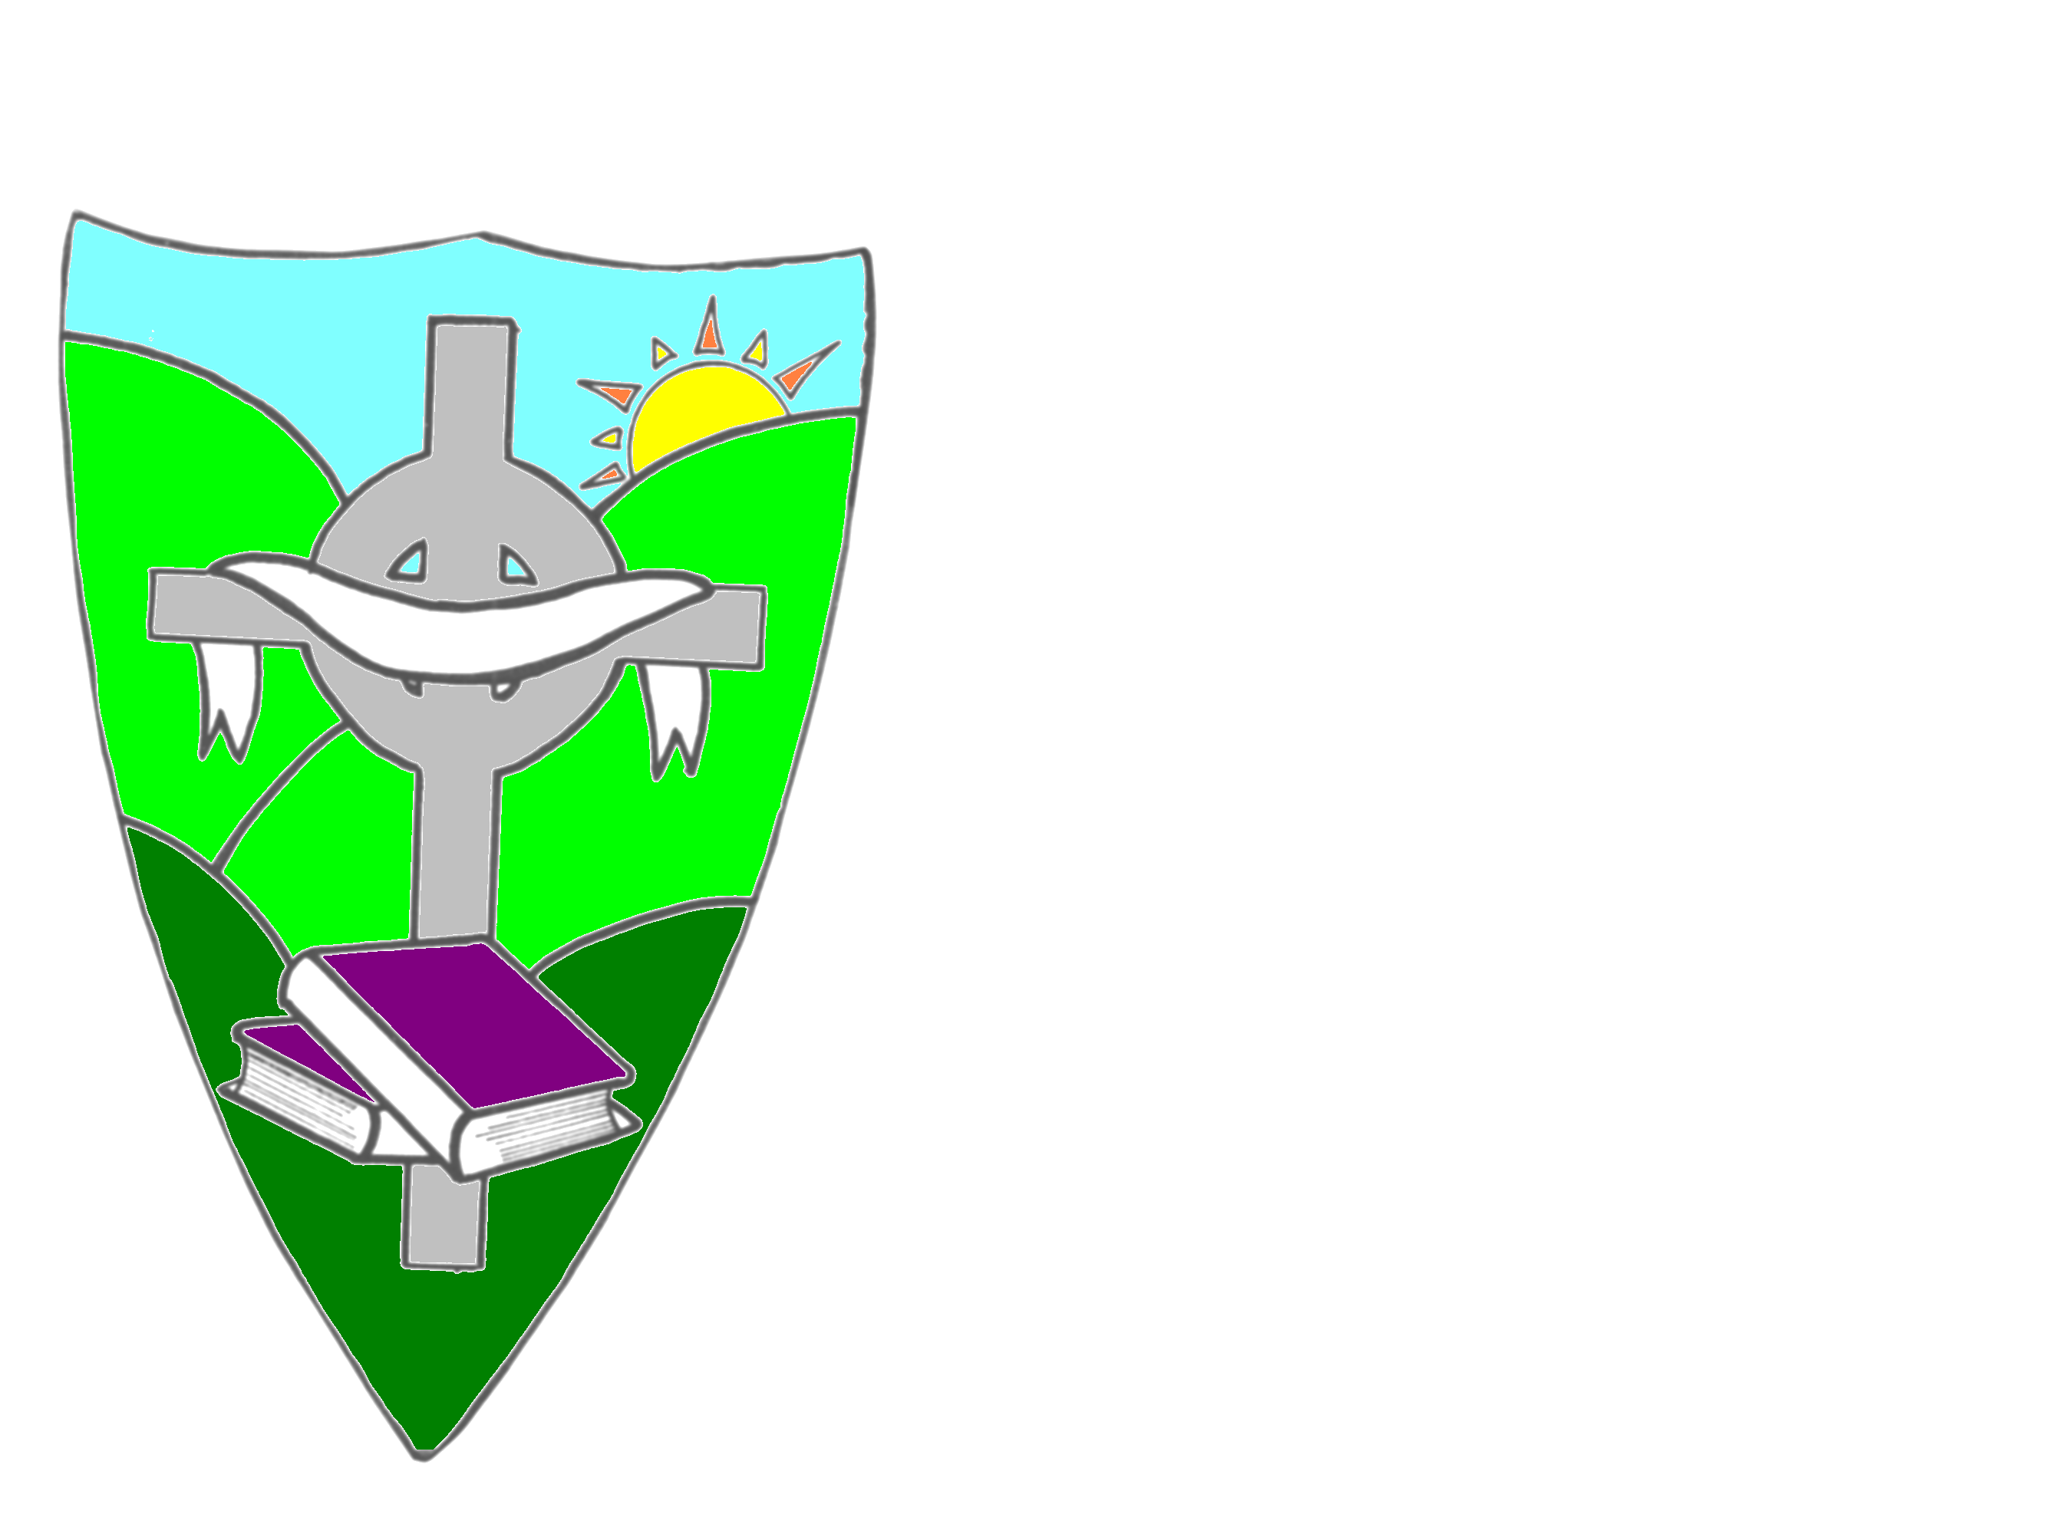

ST. MARY’S PRIMARY SCHOOL
HOLIDAY LIST 2023-24
August Thurs. 31/8/23 P1 begin school
Sept. Fri. 1/ 9/23 Term 1 begins for Primary 2-7
Mon. 25/9/23 School Closed
Oct./Nov. School closed week beginning Mon. 30th Oct. and re-opens
Mon. 6th Nov.
Dec/Jan School closes Fri. 22nd December at 11 am for Christmas
Holidays
January Term 2 starts for children Friday 5/1/24
February School closed week beginning Mon. 12/2/24 and re-opens
Tues. 20/2/24
March School closed Mon. 18th March
April School closes 11 am on Thurs. 28th March for Easter
Holidays
Term 3 starts for children Tues. 9/4/24
May School closed Mon. 6/5/24
School closed Mon. 27/5/24 and Tues. 28/5/24
June School closes Fri. 28th June at 11 am for summer holidays
Dates may be subject to change.

