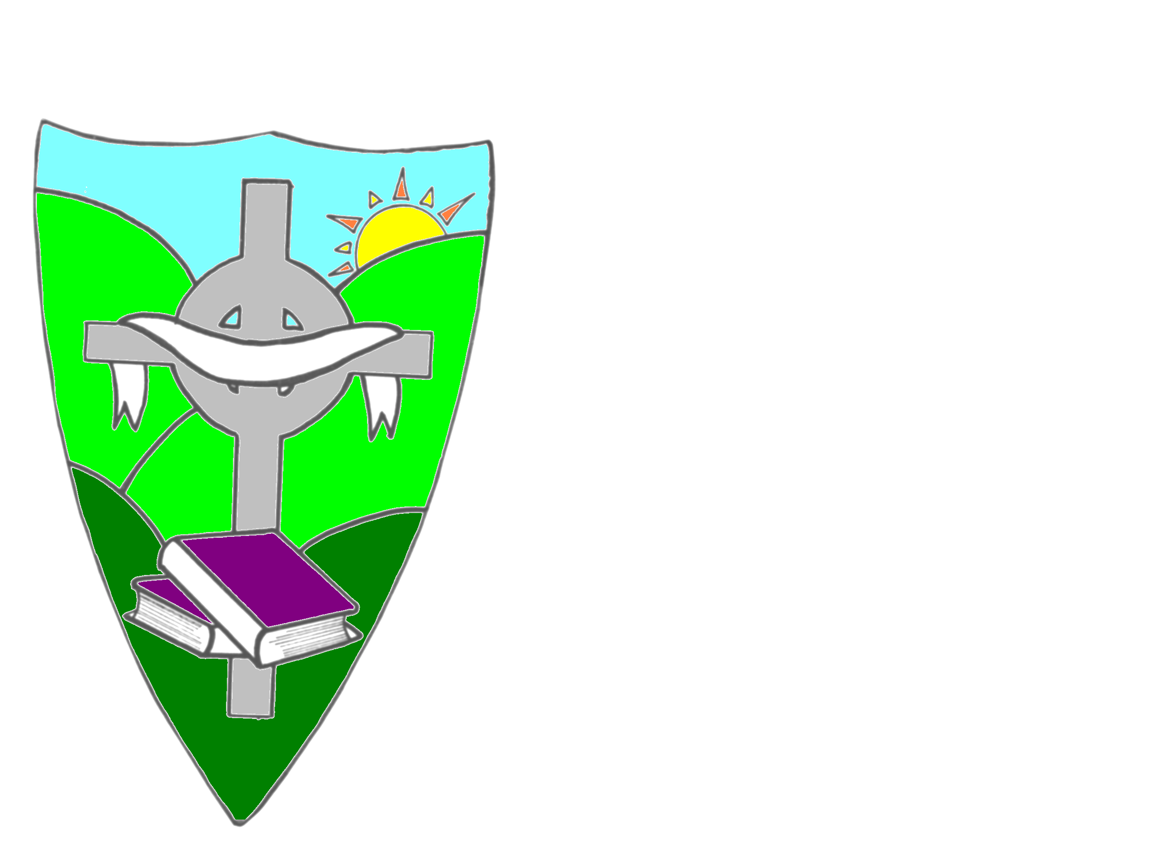 | St. Mary’s Primary School,  67 Downpatrick Street,  Rathfriland,  Co. Down,  BT34 5DQ  Tel: 028 406 30630  www.stmarysrathfriland.co.uk
13/10/22

Dear Parents/Guardians,

I hope you are all well. It has been lovely to see all the children settling quickly into school and having lots of fun and new experiences.

Some updates for you:

- Parent Teacher Meetings will take place week beginning Monday 24th October 2022.. Teachers will be in touch next week to arrange suitable times and to facilitate parents with children in different classes.

- Next week – week beginning 17th October 2022 – we will be carrying out the Autumn Standardised Tests ie Spelling, Reading etc with P3 – P7. There will be reduced Homework.

- Week Beginning 17/10/22 – we will be celebrating both Maths Week and Book Week NI in school.

- Attendance – the first Audit of Attendance by the Educational Welfare Officer will take place on Monday 24th October. I would appreciate if notes to explain absences/emails are sent in to the class teachers on your child’s return to school.

- Flu Vaccination will take place on Wednesday 26th October 2022.

- Cash for Clobber – the Cash for Clobber lorry will collect items next Friday morning. To avoid cars pulling into school grounds on Friday morning when children are arriving at school, I would appreciate if you could drop off any bags on the afternoon/evening of Thursday 20th. A poster will be shared on Facebook later to describe the items which can be included. What you don’t want can make us money!

- Halloween Party Day will take place on Friday 28th October. This is being organized by Parent Support Group. It will be £2 per child to dress up and all funds are going to Parent Support Group Fundraising.

- Drumgath GAC will be holding a Halloween Disco on the evening of Friday 28th October.

- Mrs. Fitzpatrick will be sending home details of charity fundraising. She has been talking to members of P7. We are aware that everyone is being impacted by the increase in energy prices and possible financial hardship so it was felt that it would be better to support local fundraising. More details to follow.

- School will be closed week beginning 31/10/22. We will re-open on Monday 7th^{h} November.

- Week Beginning 14th November 2022 – Anti-Bullying Week

- 21st November 2022 – P7 to attend St. Patrick’s College Taster Day.

- Drumgath Bingo Night – Friday 25th November – organized by Drumgath GAC to raise funds for both parish schools.

- O’Neill’s Online shop – I have been in regular communication with O’Neills and was told on 3/10/22 the online shop would be ready for approval to launch last Friday 7/10/22. Further communication was sent to them at the beginning of the week and today so please be patient.

- School Photographs – Tuesday 7th March – class/pupil/family photos

- Wednesday 3rd May – Whole School Photo

- Parent Support Group
- Please see the letter dated 3/10/22 on the school website regarding easyfundraising.
- The Parent Support Group Annual General Meeting will take place in the week beginning 7th November 2022.
- Swimming - It was agreed that Parent Support Group would pay for the 10th/final session for each group. P6/7 will have their last day on 15th November paid for by PSG! P5 will begin swimming on Tuesday 22nd November.

Thank you for your continued support.

Regards

M McConville

