St. Mary’s Primary School
Rathfriland

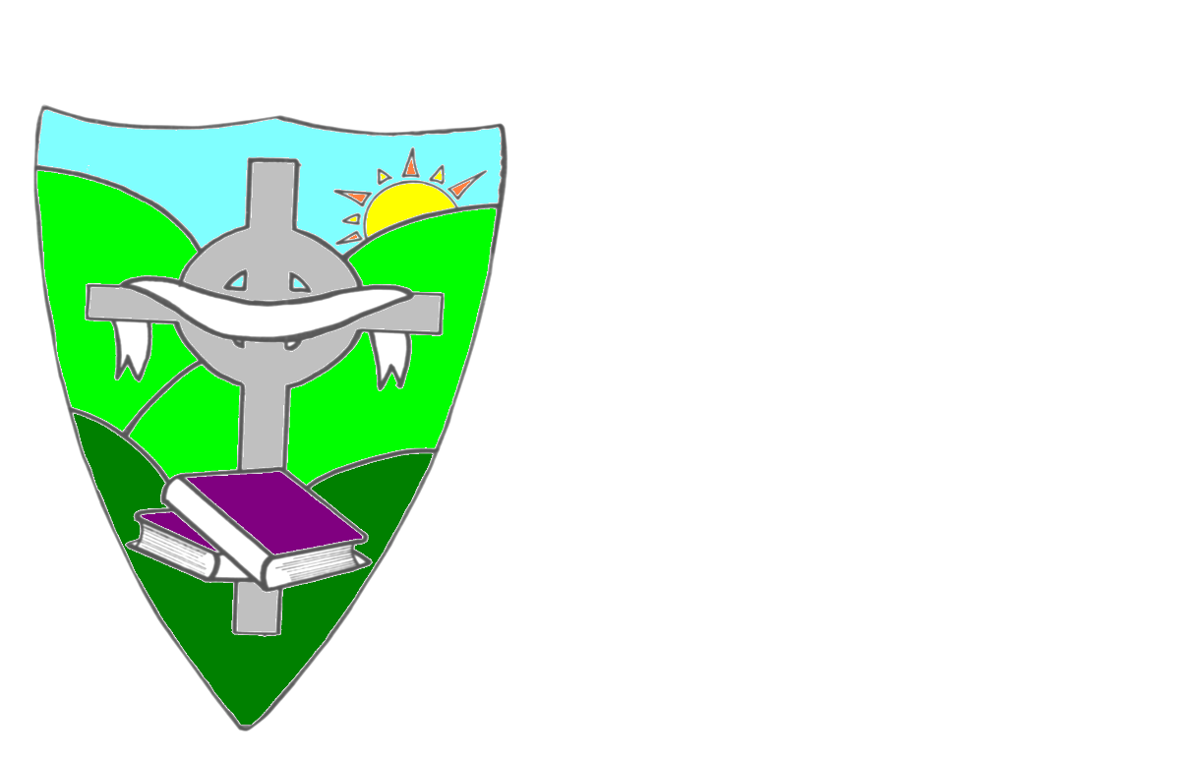

Health and Wellbeing Policy
Reviewed March 2018
Review due 2021/2022
Ratified on 13/6/18

ST. MARY’S PRIMARY SCHOOL

HEALTH AND WELLBEING POLICY

St.Mary’s P.S Mission Statement
St Mary’s Primary School is a Catholic school committed to the education of the whole child. We endeavour to create a happy and secure environment, unlocking the full potential of all individuals, thereby developing confident and independent learners.
From the Mission Statement, we in St Mary’s would aim to:

- Create an ethos that actively promotes Catholic values, with the support of parents and the parish community.

- Embrace diversity and promote respect for all.

- Celebrate our self-worth and understand our individual talents and achievements.

- Develop an environment where children feel secure to express their feelings.

- Provide a curriculum which promotes friendly relationships with the children in our care, their families, the parish and the wider community.

Rationale

In St. Mary’s Primary School we are acutely aware of our role in helping pupils to develop a healthy lifestyle. We recognise that a healthy lifestyle supports physical, social and emotional wellbeing and underpins successful learning. We see Health and wellbeing as being not only limited to classroom activities, but something which should be reinforced in all aspects of school life and life outside school.
“ A healthy, balanced diet makes an important contribution to children’s growth and development, to their educational performance and attainment and to their long-term health and well-being. The relationship between poor health, nutrition and low school achievement is well-documented.” John O’Dowd and Edwin Poots joint ministerial forward (Food in Schools Policy September 2013)
Concerns about the health, diet activity levels and the growing obesity problem amongst children and young people -From 2005/06 to 2011/12 the percentage of children in Year 8 who are overweight or obese
has increased from 27% to 31%. (Figures from Food in Schools Policy September2013) Social inclusion and inequalities in health, emphasize the importance of a focus on health and wellbeing throughout education, starting in the early years.
The Board of Governors, staff and relevant agencies work together to promote the health and wellbeing of everyone in the school community.
We recognise the importance of building good relationships, sharing and accepting responsibility, building self-esteem and reducing stress for pupils and staff wherever possible.

Aims

The main purpose of health and wellbeing education within the Curriculum is to develop the knowledge, understanding, skills, capabilities and attributes necessary for mental, emotional, social and physical wellbeing now and in the future and both inside and outside school.

At St. Mary’s we aim to:

- Create an environment, which promotes the health and well-being of all staff and pupils.
- To facilitate a cross- curricular approach to the promotion of health and wellbeing.
- Help children make informed decisions in order to improve their mental, emotional, social and physical wellbeing.
- Ensure that all aspects of school life promote positive health and wellbeing messages.
- Encourage the active involvement of parents, community and health service agencies to advise, support and contribute to the promotion of good health.
- Provide opportunities for children to experience the positive aspects of healthy living and activity for themselves e.g. Relax Kids
- Help them use their intellectual, physical, emotional and social skills to pursue a healthy lifestyle.
- Establish a pattern of health and wellbeing which will be sustained into adult life.

Overview

Health and wellbeing education in St. Mary’s includes planned and incidental learning opportunities, which are used to develop behaviours which are conducive to good health and wellbeing.
We strive to equip our children with the skills and knowledge necessary to make
informed decisions and responsible choices in matters relating to their health and well-being.
There are several dimensions to HEALTH AND WELLBEING:

- Personal Development

The children should understand the stages involved, and the factors which govern, physical , emotional and mental wellbeing.
Aspects of this strand are clearly identified and addressed in the following:
- PDMU-Personal Development Strand (Living, Learning Together)
- The World Around Us
- English: Talking and Listening
- Grow in Love religion programme
- P7 “ The Wonder of my Being” Programme
- R.I.S.E Team (Regional Integrated Support for Education)
- NSPCC “Keeping Safe”
- P.E
- Relax Kids
- Vital Nutrition

- Physical Fitness, Recreation and Relaxation

Pupils should achieve and maintain an appropriate level of fitness. They should
understand the role of recreation and the value of relaxation and sleep.
This strand is delivered primarily within the P.E. Programme and PD&MU and through the varied programme of school participation in competitions and After-school clubs. After school clubs offered include; Netball, Relax kids, Dance, Burns Skills School Healthy Kicks Programme.
We are also keenly aware of the importance of sleep in the health and wellbeing of children and actively encourage and promote this through assemblies and PD & MU.
Pupils are taught to practise personal hygiene in relation to physical activities and to acknowledge relevant rules and safety procedures.

- Healthy Eating / Nutrition

Pupils should be given the information and skills to enable them to make responsible and informed decisions about their diet and should know and understand the contribution of food to growth and health.
Children will:
- Learn about a healthy diet.
- Explore relationships between diet and health and diet and dental health.
- Participate in health promoting events such as Smile Week for Oral Health.
- Develop an understanding of and practise the safe handling of food (e.g through activities in the Cold Cookery after school club.)
- Bring fruit, raw vegetables, water or milk for break (subsidised milk is provided in school through the EU School Milk Scheme)
- Ensure that any foods brought into school are “Nut Free”
- Have access to fresh drinking water.
- Understand the importance and benefits of water in their diet.
- Be encouraged to eat a balanced lunch/dinner containing vegetables and / or fruit.
- The school participates in the D.E’s Nutritional Standards, which pays regard to nutritional balance and healthy options.
- Children are given opportunities to sample new dishes and are encouraged to try vegetables and fruit.
- Kitchen staff give awards for trying new foods at weekly assembly.
- Many children take a packed lunch and we regularly discuss contents and encourage healthy choices e.g. Food Hero Award
- We will actively promote and encourage parents to provide nutritionally well-balanced packed lunches that are high in protein, fibre, water and low in fat, sugar and salt.

The promotion of health is embedded in the school’s commitment to healthy eating as outlined in our Healthy Snacks Policy ( Appendix 1)
Much of this area is delivered through the science strand in WAUs and in the Personal Development strand of PDMU.

- Drugs and Harmful Substances.

Pupils should develop their knowledge and understanding of the use, misuse, risks and effects of drugs, smoking and other potentially harmful substances.
These issues are dealt with as part of PD & MU. The school also addresses misuse of substances as part of the P.7 preparation for the Sacrament of Confirmation.
The school premises are a non-smoking zone and a member of staff wishing to smoke is permitted to do so in their own car in the staff car park if necessary. See also St. Mary’s Drug Policy for further detail.

- Relationships within the Family.

Through sensitive discussion and study, children should recognise the importance of the family unit and the part each member can play.
They will consider the roles and responsibilities of family members. This will be dealt with through the delivery of the Grow in Love religion programme, NSPCC “Keeping Safe Programme” and through the PD&MU programme.

- Relationship with Peers.

Children will be given the opportunities to explore friendships, peer pressure and the influence of peer groups. They will be encouraged to develop and practise a sense of fair play, tolerance, sharing and co-operation. These issues will pervade every day school life and are delivered specifically through the Grow in Love programme, NSPCC “Keeping Safe Programme”,“The Wonder of My Being” and the Mutual Understanding strand of PD&MU

- Relationships with Others.

Children will come to understand the nature of relationships with others and through recognition of the school ethos and commitment to our Christian values system will begin to establish responsible relationships within a widening community. As well as becoming more confident in communicating with adults and handling social relationships, children will be given strategies to protect themselves in potentially dangerous situations. Issues pertaining specifically to this are addressed in the Mutual Understanding strand of PD&MU, NSPCC
“Keeping Safe Programme” and in the “The Wonder of My Being” programme delivered in P7.

- Personal Safety in the Environment.

Children should be able to cope safely and efficiently with their environment.
This involves helping children to:
- Develop an understanding and practise of the principles of Road Safety through the various Road Safety initiatives from Department of Infrastructure eg Junior Road Safety Officers, Cycling Proficiency and Walk to School Week
- Be aware of the importance of a responsible approach to safety in the home and school environment through the involvement of various organisations invited into school to talk to the children eg. Northern Ireland Fire and Rescue Service, Farm Safety, participation in Banbridge District Community Safety Partnership- BEE SAFE day.
- Understand the importance of Online Safety and how to protect themselves in the virtual environment.
- Children from P4-P7 are offered 12 weeks of swimming lessons at Banbridge Leisure Centre.
- Promoting Healthy Eating by inviting outside agencies in e.g. Vital Nutrition.

- A Healthy Environment.

Children will also consider the environmental factors which can affect health. They will have the opportunity to explore how the use of some natural resources can have a harmful effect on the environment. They will come to understand how improvements can be made in their own locality to maintain healthy surroundings and will be aware of the part that they can play in this.

Roles and Responsibilities Staff.

All staff will actively support, contribute to and be involved in the promotion of good health. All staff will participate in staff development as and when necessary and various agencies are invited in to promote healthy eating and lifestyle.

Parents.

We in St. Mary’s recognise the important role parents play in helping us promote good health. Parents are asked to support the school by encouraging their children to participate in sports and After-School activities and in the
provision of healthy snacks for break and lunches and ensuring food brought into school complies with our Nut Free Food Policy. Parents will also be made aware of the importance of sleep to their children at curriculum meetings at the beginning of the year. Any information from Government and Government Agencies regarding health and wellbeing will be communicated to parents.

Governors
The Governors will monitor the implementation of this policy and evaluate with the Principal.

Advice, information and guidance from the following agencies were used in the
formation of this policy and the delivery of Health and Wellbeing.
- Education Authority
- HSC Public Health Agency
- Food in Schools Policy September 2013
- Top Marks Nutritional Standards for other food and drink in schools.
- Top Marks Nutritional Standards for school lunches.
- Healthy Break Policy

This Policy will be monitored and updated in line with statutory requirements and reviewed in 2021

APPENDIX 1

St. Mary’s Primary School
Healthy Snacks Policy

Aim
To promote the development of a positive approach to Healthy Eating.
Objectives
- To encourage children to drink water.
- To encourage drinking milk through the EU School Milk scheme.
- To encourage children to eat fruit or raw vegetables at break time.
- To encourage parents to support our Healthy Breaks initiative by providing the appropriate food/drink and ensuring any snacks in lunch boxes are free from nuts (anything other than what is listed above will not be allowed to be consumed at break time)
- To encourage parents to carry this approach to lunch/dinner and lifestyle outside school.
- To support the Board of Governors in their commitment to our Health & Wellbeing Programme.

We in St Mary’s have your child’s best interests at heart and therefore food and drink which does not comply with our Healthy Break Policy will not be allowed to be consumed at mid-morning break. The sharing of healthy break is not encouraged.

