St. Mary’s Primary School
Rathfriland

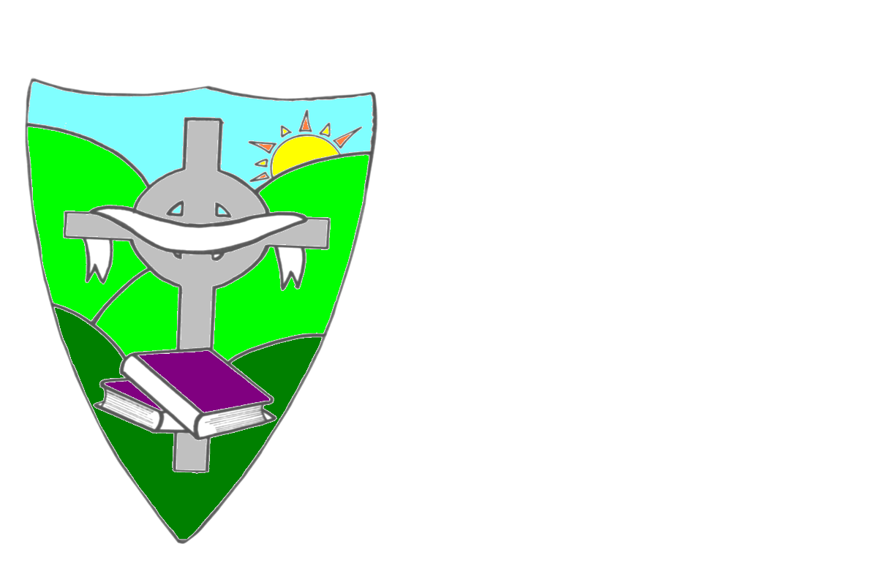

Drugs Policy
Policy Date: June 2018
Next review Date 2021/2022
Ratified on 13/6/18

ST. MARY’S PRIMARY SCHOOL

DRUGS POLICY

St.Mary’s P.S Mission Statement
St Mary’s Primary School is a Catholic school committed to the education of the whole child. We endeavour to create a happy and secure environment, unlocking the full potential of all individuals, thereby developing confident and independent learners.
From the Mission Statement, we in St Mary’s would aim to:

- Create an ethos that actively promotes Catholic values, with the support of parents and the parish community,

- Embrace diversity and promote respect for all,

- Celebrate our self-worth and understand our individual talents and achievements,

- Develop an environment where children feel secure to express their feelings.

- Endorse the United Nations’ Convention for the Rights of the Child.

- Provide a curriculum which promotes friendly relationships with the children in our care, their families, the parish and the wider community.

Rationale.
In St. Mary’s we are committed to providing the children in our care with the necessary knowledge and skills to understand what is meant by the term “Drugs”. We are aware that staff may also need support with alcohol or drugs and so our aim is to :
- Provide drug awareness messages which are age appropriate and taught as part of our preventative curriculum.
- To provide a constructive and preventative strategy regarding drugs and alcohol problems amongst our employees.

Definition.
For this policy, the term drug and substance include any product that, when taken, has the effect of altering the way the body works or how a person behaves, feels, sees or thinks.
As well as everyday products such as tea and coffee, substances include;

- alcohol, tobacco and tobacco-related products, including nicotine replacement therapy (NRT) and electronic cigarettes;
- over-the-counter medicines such as paracetamol and cough medicines;
- prescribed drugs, such as antibiotics, painkillers, antidepressants, antipsychotics, inhalers and stimulants such as Ritalin;
- volatile substances such as correcting fluids or thinners, gas lighter fuel, aerosols, glues and petrol;
- controlled drugs such as cannabis, LSD, ecstasy, amphetamine sulphate (speed), magic mushrooms, heroin and cocaine;
- new psychoactive substances (NPS), formerly known as legal highs*, which contain one or more chemical substances that produce similar effects to illegal drugs and are sold as incense, salts or plant food marked ‘not for human consumption’ to avoid prosecution;
- other substances such as amyl or butyl nitrite (known as poppers) and unprocessed magic mushrooms

*The term ‘legal high’ is no longer used as it is misleading. The public perceived that ‘legal’ meant safe, but as these substances are not regulated there is no way of knowing what chemicals they contain
(CCEA Drugs Guidance for Schools 2015)

Pupils.
We are aware in St. Mary’s that children and young people are exposed to messages about drug use from an early age. Their exposure to the use and misuse of drugs may come from television, the media, popular music, family and older siblings. Therefore we need to have procedures in place to deal with any events that may arise, as well as fulfilling our statutory obligations to have a Drugs Policy in place.
The Designated Teacher for drugs in St. Mary’s is Mrs Jane Fitzpatrick and the Deputy Designated Teacher is Mr Niall Donnan

Drugs education will be delivered through our preventative curriculum and will be age appropriate.
The preventative curriculum will help in developing self-esteem and empowering our pupils with the skills necessary to assert themselves confidently and resist negative pressures and influences. It will provide opportunities to develop the values, skills, knowledge and understanding necessary to make informed and responsible decisions about the use / misuse of drugs, including tobacco, tobacco related products, alcohol, e cigarettes, prescription and non- prescribed drugs, within the context of a healthy lifestyle. It will be delivered through:
- NSPCC keeping Safe Programme
- Grow in Love religion programme
- PD & MU

Staff.
Drugs and alcohol problems can affect an individual’s health and wellbeing and cause a range of social problems as well as impacting on job performance and career prospects.

The school recognises that drugs and alcohol related problems require employees receiving the necessary help and treatment.
In such circumstances the Principal and the Board of Governors will do all in their power to offer the employee the necessary support to help with their problem and will assist the employee in accessing the necessary support from outside agencies.
Any discussions with an employee in connection with any issue will be strictly confidential.

Procedures.
If a drugs or substance abuse issue is discovered or related to the school, the Designated Teacher will be informed, and she will follow the procedures outlined in Appendices 1 to 5.
A record of actions taken will be kept and held in the secure cupboard and a report will be prepared for the Chair of the Board of Governors and the designated officer in CCMS.
The role of the Designated Teacher for drugs.

Mrs Jane Fitzpatrick is the designated teacher with responsibility for drugs and for handling cases of suspected drug misuse on the premises.
The Designated Teacher for Drugs is responsible for:
• Co-ordinating the school’s procedures for handling suspected drug-related incidents and training and inducting new and existing staff in these procedures.
• Being the contact point for outside agencies that may have to work with the school or with a pupil or pupils concerned.
• Informing the Principal, who should contact the pupil’s parents or carers immediately.
It is the responsibility of the designated teacher for drugs to take possession of any substance(s) and associated paraphernalia found and complete a factual report.

The Principal.
It is the Principal’s responsibility to determine the circumstances of all incidents, but it is the responsibility of the PSNI to investigate any criminal or suspected criminal offence. In any suspected drug related incident, the Principal should contact the parents / carers of those pupils involved. The Principal must ensure that in any incident involving a controlled substance that there is close liaison with the PSNI. Failure to inform the PSNI of a suspected incident involving controlled drugs is a criminal offence.
After contacting the PSNI, the Principal should confine their responsibilities to:
- The welfare of the pupil(s) involved in the incident and the other pupils in the school.
- Health and safety during the handling, storage and safe disposal of any drug or drug-related paraphernalia, using protective gloves at all times.
- Informing the Board of Governors.
- Agreeing any appropriate pastoral or disciplinary response.
- Reporting the incident to the CCMS if appropriate, for example if an incident:
- Is serious enough to require PSNI involvement.
- Requires that a child protection procedure is invoked, or leads to the suspension or exclusion of a pupil.
- Completing a written report and forwarding a copy to the Board of Governors and the designated officer in the CCMS.
The Role of the Board of Governors.
The Board of Governors are responsible for ratifying the policy and will be informed by the Principal of any incidents and the actions taken.

Finding drug-related paraphernalia.
Paraphernalia in the school grounds is an indication of drug use or misuse. Any member of the school community who encounters any paraphernalia should use extreme care, as these items may be hazardous. Anyone who finds paraphernalia associated with drug use or misuse should report it to the designated teacher for drugs, who will assess the situation and respond accordingly. This response may include contacting the PSNI.

Staff Policy on Smoking and Alcohol.
St.Mary’s P. S. is a smoke (including e-cigarettes) and alcohol free zone.

Confidentiality.

Should a pupil reveal any personal drugs information, which puts them or any other pupil at risk, this must be passed on to the designated teacher / Principal. Confidentiality can never be guaranteed, as we are responsible for the protection and safeguarding all the pupils in our school.

Guidance on the Administration of Medication in School.

Please refer to the school policy on the Administration of Medication.

Monitoring and Evaluation.
This policy will be reviewed every three years and / or after any drug related or suspected drug related incident to see if there are improvements to be made.

The following material was used in developing this policy.
- Drugs Guidance for Schools CCEA revised 2015

Managing an Incident Appendix 1

Individual staff members should:
- Assess the situation and decide the action.
- Make the situation safe for all pupils and other members of staff, secure first aid and send for additional staff support, if necessary;
- Carefully gather up any drugs and / or associated paraphernalia or evidence and pass all information or evidence to the designated teacher for drugs.
- Write a brief factual report of the incident and forward it to the designated teacher for drugs.
The Designated Teacher for drugs should:
- Respond to the first aider’s advice or recommendations.
- Inform parents or carers immediately, in the case of an emergency.
- Take possession of any substance(s) and associated paraphernalia found.
- Inform the principal.
- Take initial responsibly for pupil(s) involved in the suspected incident.
- Complete a Drugs Incident Report Form and forward it to the Principal.
The Principal should:
- Determine the circumstances surrounding the incident;
- Ensure that the following people are informed: parents / carers, designated officer in the local PSNI area.
- Board of Governors; and o designated officer in CCMS.
- Consult and agree pastoral and disciplinary responses, including support.
- Forward a copy of the Incident Report Form to the Chairperson of the Board of Governors and the designated officer in the CCMS.
- Review procedures and amend, if necessary.

Handling Drug-Related Incidents Appendix 2

On finding a suspected substance or drug-related paraphernalia on or close to the school premises.

Inform the principal / designated teacher for drugs.

Make the situation safe for pupils and staff.

Arrange for removal of items using protective gloves.

Bring the substance and any related paraphernalia to the designated teacher for drugs / principal to be stored in a sure place.

Contact the PSNI and hand over the substance for analysis ensuring that feedback will be provided to the school.

Record actions taken.

Investigate and record how the substance can to be on the school. premises.

Inform the CCMS designated officer using the Drugs Incident Report Form if appropriate.

Prepare a report for the Chair of the Board of Governors as appropriate.

Recognising Signs of Substance Abuse Appendix 3
What to look out for.
If someone is having a bad time on drugs, they may be:
- Anxious
- Tense
- Panicky
- Overheated and dehydrated
- Drowsy
- Have difficulty with breathing
What to do.
The first things you should do are:
- Stay calm and get First Aider.
- Calm them and be reassuring, don’t scare them or chase after them.
- Try to find out what they’ve taken.
- Stay with them.
If they are anxious, tense or panicky, you should:
- Sit them in a quiet and calm room.
- Keep them away from crowds, bright lights and loud noises.
- Tell them to take slow deep breaths.
- Stay with them.
If they are really drowsy, you should:
- Sit them in a quiet place and keep them awake.
- If they become unconscious or don’t respond, call an ambulance. immediately and place them in the recovery position.
- Don’t scare them, shout at them or shock them.
- Don’t give them coffee to wake them up.
- Don’t put them in a cold shower to ‘wake them up’.
If they are unconscious or having difficulty breathing, you should:
- Immediately phone for an ambulance.
- Place them into the recovery position.
- Stay with them until the ambulance arrives.
- If you know what drug they’ve taken, tell the ambulance crew, this can help make sure that they get the right treatment straight away.
Appendix 4
A parent or carer arrives at school to collect a child and appears to be under the influence of alcohol or another substance.
1.Parent or carer suspected of being drunk/high.

2.Discretely detain the pupil in the classroom and send for the Principal/ designated teacher.

3.Principal speaks to the parent or carer to assess the situation.

4.Can the pupil be released to the parent or carer?

YES NO
Contact another relative to come and collect the child.

Release the pupil to their parent or carer once the principal is satisfied that it is safe to do so.

Ask the parent or carer to come into the school to quietly discuss the school’s concerns.

Contact social services in line with the school's Safeguarding and Child Protection Policy.

If the parent or carer becomes violent, tries to forcibly remove the child or intends to drive while under the influence, contact PSNI.

Write a detailed report of the incident including action taken.

Inform the chair of the Board of Governors as appropriate.

Inform the CCMS designated officer using the Drugs Incident Report Form if appropriate

Appendix 5.
St. Mary’s P.S.
Drugs Incident Report Form
1. | Name of Pupil _________________________________DOB ________________  Address __________________________________________________________
2. | Date of incident_____________________Reported by_____________________  Time of incident__________________Location___________________________
3. | First Aid given Yes/No By ___________________________________________  Ambulance/Doctor called Yes /No Time of call
4. | Parent or carer informed YES/NO Date ________________________  Time __________________
5. | Where substance is retained ________________________________________________ or  Date substance destroyed or passed to PSNI _____________ Time __________
6. | PSNI informed YES/NO  Date ________________________ Time __________________
7. | CCMS Designated Officer informed YES/NO  Date ________________________ Time __________________
8. | Form completed by _____________________________________  Date _______________ Position___________________________________________________________

Description of the Incident
______________________________________________________________________________________________________________________________________________________________________________________________________________________________________________________________________________________________________________________________________________________________________________________________________________________________________________________________________________________________________________________________________________________________________________________________________________________________________________________________________________________________________________________________________________________________________________________________________________________________________________________________________________________________________________________________________________________________________________________________________________________________________________________________________________________________________________________________________________________________________________________________________________________________________________________________________________________________________________________________
Actions taken
______________________________________________________________________________________________________________________________________________________________________________________________________________________________________________________________________________________________________________________________________________________________________________________________________________________________________________________________________________________________________________________________________________________________________________________________________________________________________________________________________________________________________________________________________________________________________________________________________________________________________________________________________________________________________________________________________________________________________________________________________________________________________________________________________________________________________________________________________________________________________________________________________________________________________________________________________________________________________________________________
Incident form completed by
Date

