Daily Mile Santa Run!

On Friday 2nd December we will be joining hundreds of schools by taking part in the Daily Mile Santa Run. If you have a Christmas hat or headband, please be sure to wear it to school to add some festive cheer while we run.
Watch this space for lots of photos!

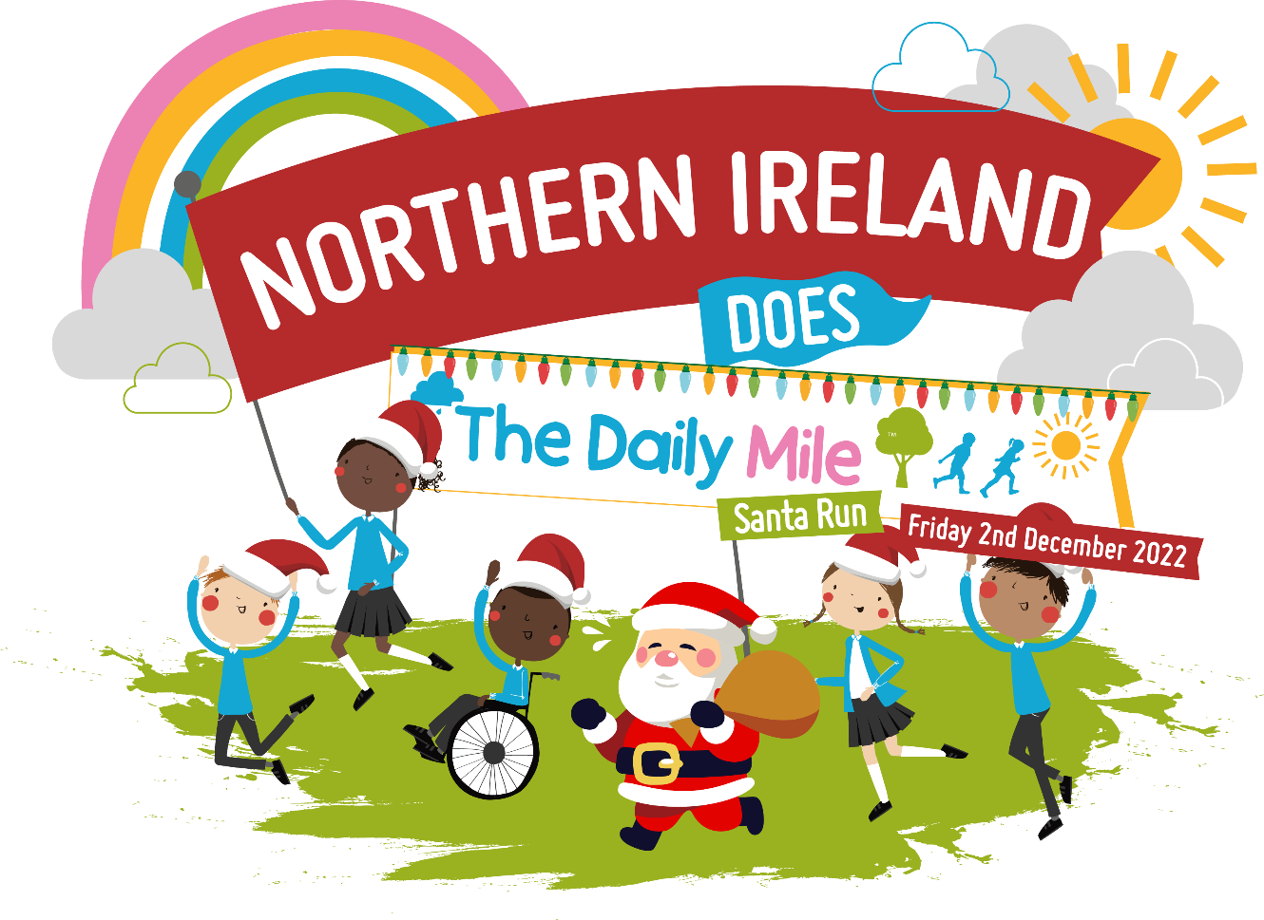
HO! HO! HO!

