**Water Week in St. Mary’s!**

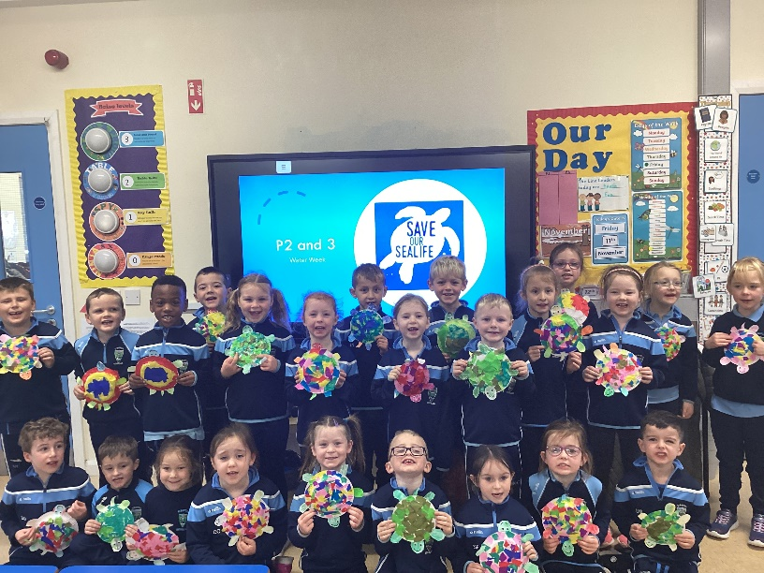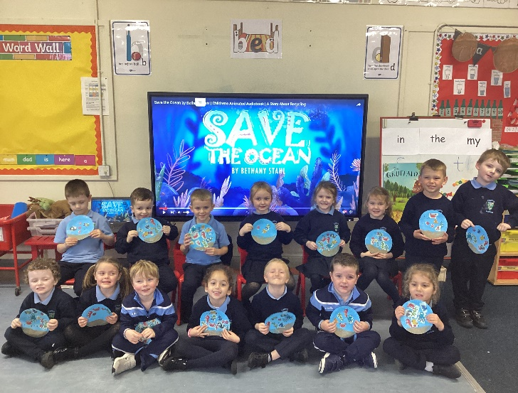

**P1, 2 and 3 watched a video about a poor turtle who kept eating plastic bags as he thought they were jellyfish. They talked about sea pollution and how we can all help keep our oceans clean and our sea life safe.**

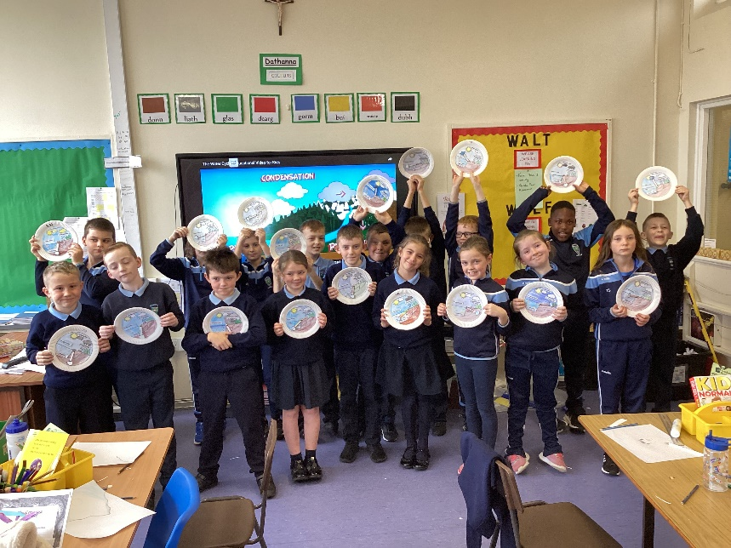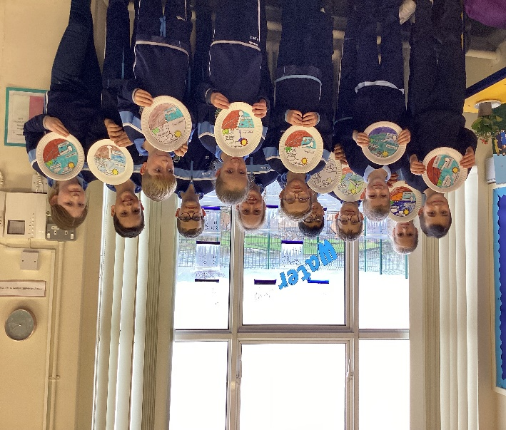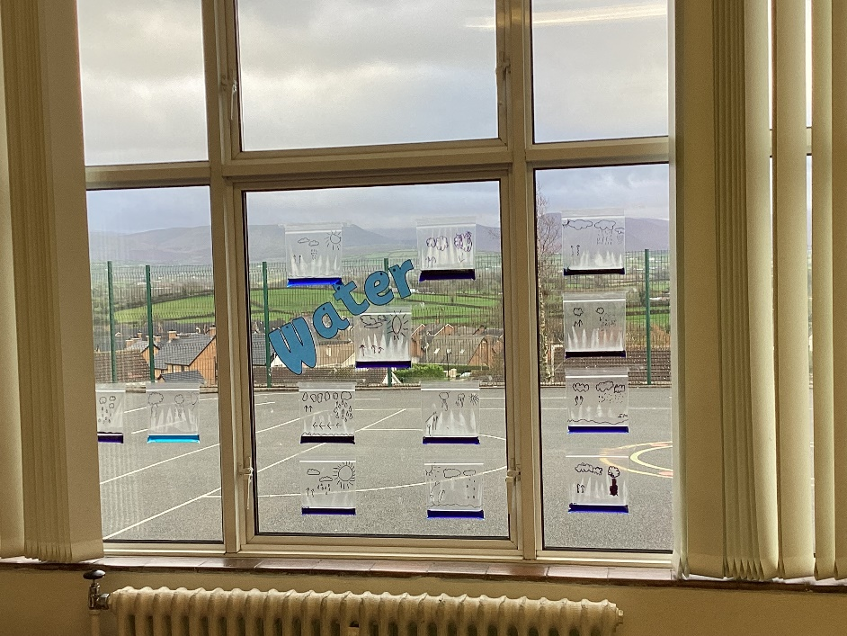

**P4 and 5 explored the Water Cycle, made a ‘Water cycle in a bag’ model and discussed the consequences of climate change on the water cycle.**

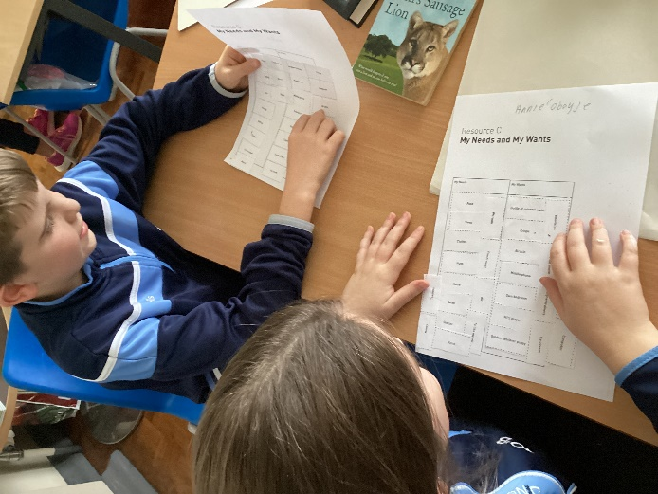

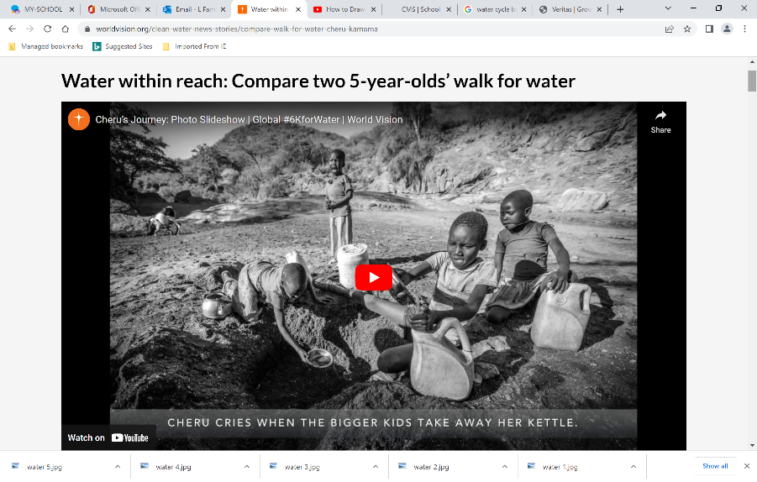

**P6 and 7 evaluated needs and wants, the rights we have, and completed ‘Buckets of Fun Challenge’ to compare our lives to the lives of others in countries which unfortunately don’t have access to clean water.**

