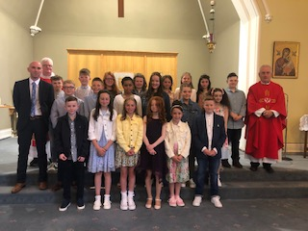

CONFIRMATION IN ST. MARY’S

Congratulations to all our P7 class. Thank you to Mr. Donnan for preparing the children, assisted by Mrs. Fitzpatrick. The beautiful singing and music – thank you to P7 and Miss Walsh.

